**PJ 5 Report My Name: ___Yaowei Lei__**

**A. The following is my Python source program:**

**// Please copy your source program into here from your Visual Studio IDE.**

**// Your code here must be in color. You must not show screen prints here.**

#-----------------------------------------------------------------------------------------------------------.

# Author: Yaowei Lei

# Date: 11/07/2021

# Purpose: CS119-PJ5: Password Game – to check whether a password is very secure.

#------------------------------------------------------------------------------------------------------------.

n = 1 # line number for each separator line

print ("Welcome to the PASSWORD game of \"Yaowei Lei\"!")

print (n,"============================================================"); n+=1;

pw = input( "Please enter a password (Enter q to quit): ") # pw is a string

while (pw != "q") : # q is to quit the game and exit this loop

print("The password you just entered is \"" + pw + "\"") # password is quoted for clarity

badcount = 0 # count # of problems

letters = " " # collect all the letters in pw

countdigits = 0 # count # of digits

countsymbols = 0 # count # of 6 special symbols $ % @ ! ? *

countlower = 0 # count # of lower-case letters

countupper = 0 # count # of upper-case letters

countyears = 0 # count # of 4-digit years 2020 2019 2018 2017

# Collect all the letters in pw and count how many digits:

for item in pw :

if item.isdigit( ) :

countdigits += 1

elif item.isalpha( ) :

letters += item

# Counting how many upper case letters and lower case letters in 'letters':

for item in letters :

if item.isupper( ) :

countupper += 1

else :

countlower += 1

if (countupper < 2) :

print("R1: Your password is not secure since it has less than 2 upper-case letters.")

badcount += 1

if (countlower < 2) :

print("R2: Your password is not secure since it has less than 2 lower-case letters.")

badcount += 1

if ( len(pw) < 7) :

print ("R3: Your password is not secure since it has less than 7 characters.")

badcount += 1

if (countdigits < 2) :

print( "R4: Your password is not secure since it has less than 2 digits.")

badcount += 1

if ( len(pw) > 12) :

print ("R5: Your password is not secure since it has more than 12 characters.")

badcount += 1

if pw.count(' ') > 0 : # space character ' ' check

print( "R6: Your password is not secure since it contains space.")

badcount += 1

if pw.isdigit( ) : # isdigit( ) will check whether pw contains only digits.

print( "R7: Your password is not secure since it contains only digits. ")

badcount += 1

if pw.isalpha( ) : # isalpha( ) will check whether pw contains only alphabets.

print( "R8: Your password is not secure since it contains only alphabets. ")

badcount += 1

# Counting 6 special symbols:

countsymbols += pw.count('$') +pw.count('%') + pw.count('@') + pw.count('!') + pw.count('?') + pw.count('*')

if (countsymbols <= 0) :

print( "R9: Your password is not secure since it contains none of 6 special symbols: $ % @ ! ? *")

badcount += 1

# Counting 4 special years:

countyears += pw.count('2020') + pw.count('2019') + pw.count('2018')+pw.count('2017')

if (countyears > 0) :

print("R10: Your password is not secure since it contains 2020, 2019, 2018, or 2017.")

badcount += 1

# Final check of badcount to see whether password is very secure:

if (badcount == 0) :

print( "Congratulations! Your password is very secure!")

else :

print( "Your password has the above ", badcount, " problems to be fixed." )

print (n,"============================================================"); n+=1;

pw = input( "Please enter a password (Enter q to quit): ")

# end of while loop

print (n,"============================================================"); n+=1;

print("Thank you for playing this PASSWORD game of Yaowei Lei! ") # must use your name!

print (n,"============================================================"); n+=1;

# End of MAIN PROGRAM ============================================.

**B. The following is the console output of my 3 test runs:**

**// One way to copy the console output is to press Ctrl+Alt+PrtScn, which is a screen print.**

**// Another way to copy is to use the snipping tool. To paste the image is to press Ctrl+v.**

**// The console display must not be too wide, otherwise it will be too hard to read once pasted.**

**// Please make sure your console is long enough to show all your output lines, and is readable.**

**// Please copy your console output and paste into here:**

**Test Run #1:**

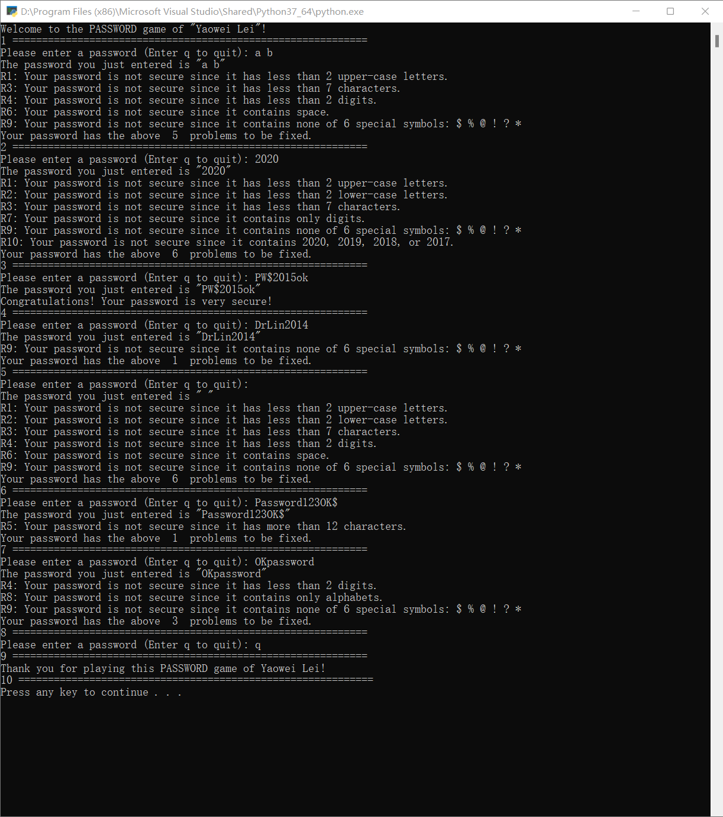

**Test Run #2:**

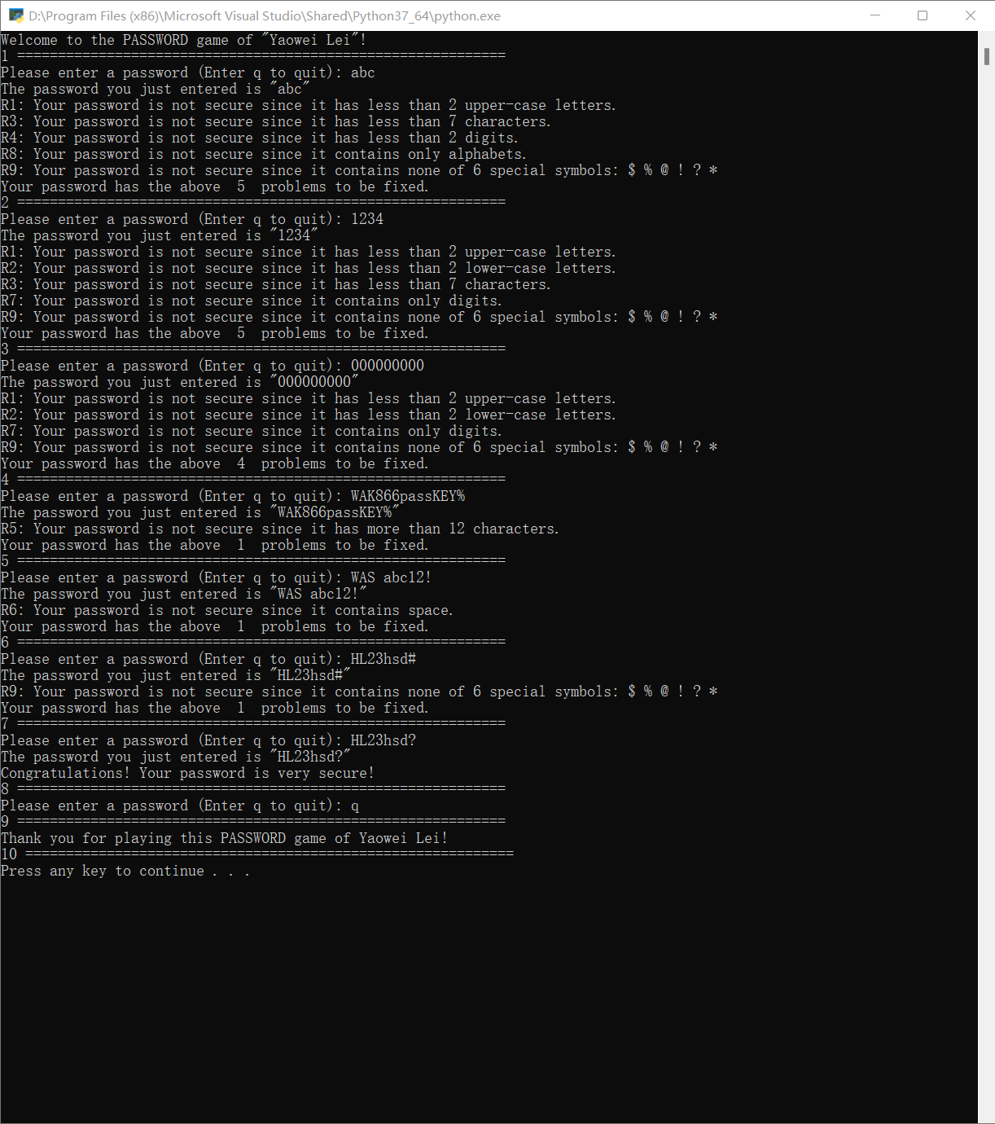

**Test Run #3:**

